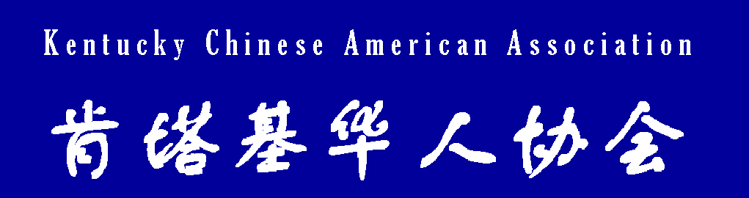

For more information about Shillito Park visit: http://www.lfucg.com/parks/documents/shillito_shelter.pdf

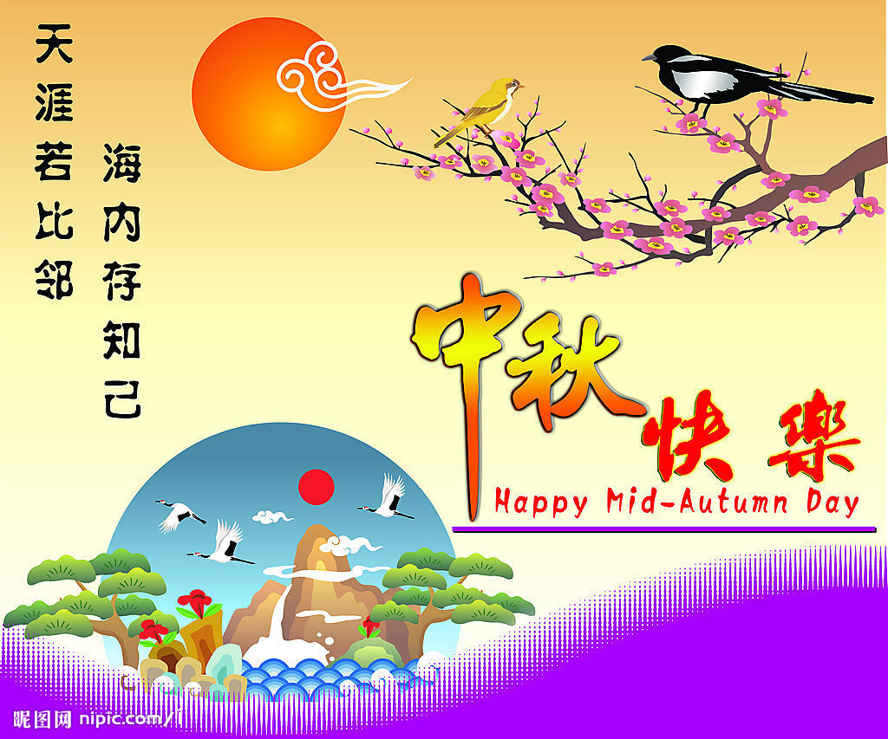
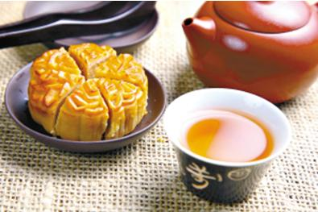



FREE Picnic Menu by KYCAA:
Moon cake
BBQ/Hot dogs/Burgers
Sichuan noodles
Snacks
Drinks

And more….

ACTIVITIES:
Talent show
Taste and sale of Moon cakes
Contest for home made moon cakes
Essay contest about Moon festival Chinese riddles
Folk dance demo, and parade
Badminton, Volleyball, Tug-o-war etc
…Or bring your own game games!
Bring Your Families and Friends for a Great Time Together!
For more information, please visit www.kycaa.org or call (859)913-2067

POT LUCK: Please bring your favorite dishes to share…

